Create one e2e test (Login >Creating course > Delete Course >Logout)

Create local branch with ur name

Create pull request for merge branch

Solution:

Step 1 : Created e2e flow

Step 2 : Created local branch with name [junaidshaikhtest](https://github.com/Junshaikh/junaidshaikhtest)

Step 3 : Run these commands to push the code to local branch

git init

git add .

git commit -m “pushing code to github”

git remote add origin [git@github.com](mailto:git@github.com):Junshaikh/junaidshaikhtest.git

git push -u origin master

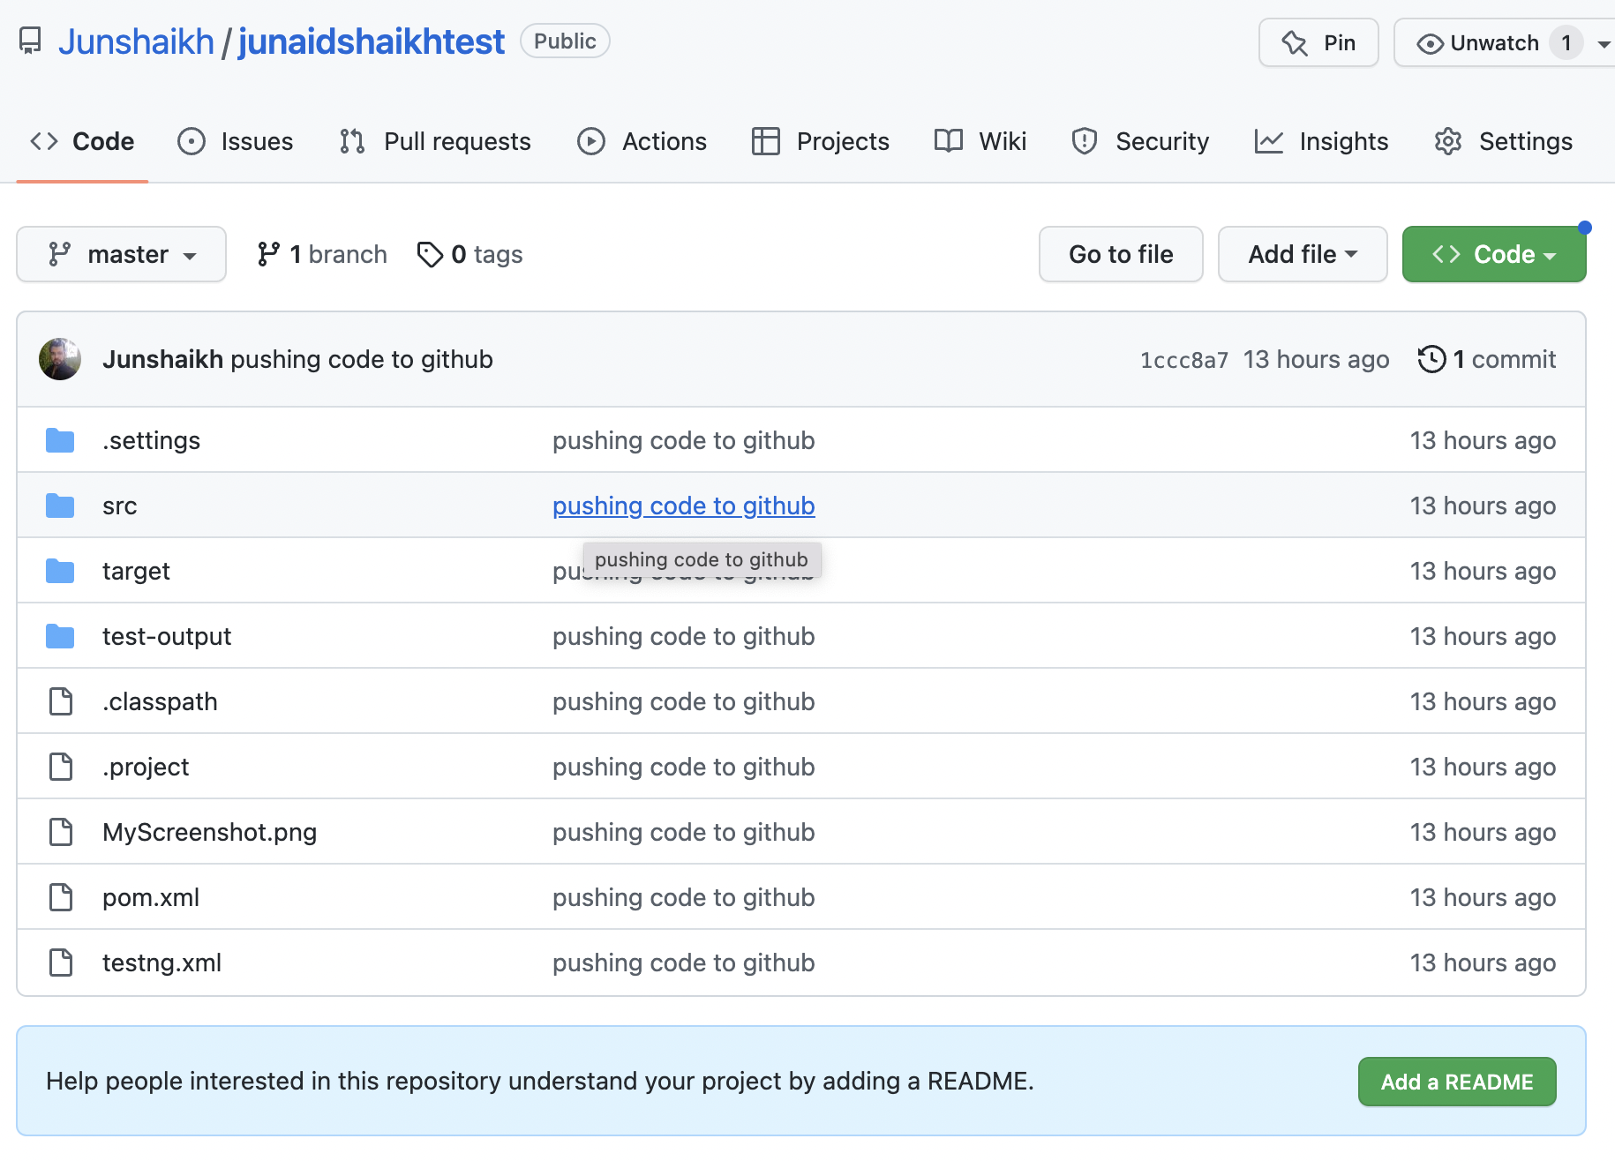

Step 4 : Done some changes in the createcourse and delete file and then run pull command

git pull

